**4. Implementation of Security Policy**

**Aim :** To implement security policies in Ubuntu OS environment.

**Procedure**

1. Log on to goorm.io IDE
2. Create a new container for Ubuntu operating system(**Ubuntu 18.04 TLS**) and run the container.
3. Select terminal window by pressing **Alt+Shift+T** or select **New Terminal window** option from **Window** menu
4. Install the text editor **‘nano’** by typing the following command in prompt

**#apt-get install nano**

1. Install the password manager tool by typing the following command in prompt.

**#apt-get install libpam-pwquality**

1. Go to **/etc/pam.d** directory (**#cd /ect/pam.d** )
2. Open **common-password** file using **nano** editor(**#nano common-password**).
3. Update the **common-password** file to implement password polices as

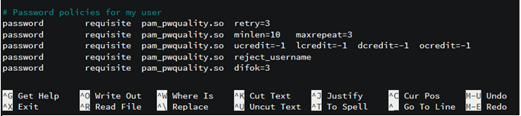

1. Save and Exit from nano editor(**Ctrl+O and Ctrl+X**)
2. Verify the password policy by setting new password for existing user or create new user and password.

**#useradd user1 or #adduser user1**

**#passwd user1**

1. Update login.dfs file for password expiry and notification.(**#nano /etc/login.dfs**)

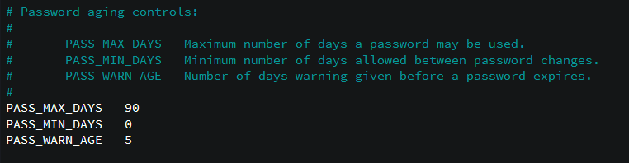

1. Save and Exit from nano editor(**Ctrl+O and Ctrl+X**)